# 02. The Squirrel

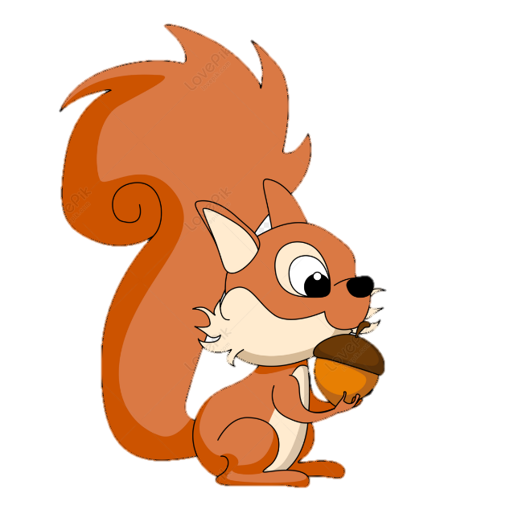

*An intern from a big company must solve the game - "The squirrel". He doesn’t have enough experience, so he needs your help.*

**Here are the rules of the game:**

The game starts with 0 collected hazelnuts. **Your goal is to collect 3 of them.**

You get as input the size of the field, which will be always a **square shape**. After that, you will receive the directions in which the squirrel can move – **"left"**, **"right"**, **"down"**, and **"up"** in a sequence, each value separated by a comma and a space (**", "**). On the next rows, you will receive the field.

Possible characters in the field:

* **s** - represents the squirrel's position.
* **h** – represents a hazelnut.
* **\*** – the asterisk represents an empty position.
* **t** – represents a trap.

The squirrel starts from the **s - position**.

* If the squirrel steps on a hazelnut, you have to **increase them by 1**. The position should be marked with an **asterisk** (**\***).
  + If the squirrel **collects all 3 hazelnuts**, the game ends and the **squirrel stays in its last position**.
* **Asterisk (*) does nothing**, so nothing happens if the squirrel **steps on** it.
* If it steps on a trap, **the game ends and the squirrel disappears from the screen**.
* If the squirrel moves **out** of the field, **the game ends and disappears from the screen**.

After all commands you will have 4 possible results:

* **You win if the squirrel collects 3 of the hazelnuts.**
* **The squirrel collects less than 3 hazelnuts.**
* **The squirrel steps on a trap.**
* **The squirrel moves out of the field.**

### Input

* **On the first line, you will receive the length of the field – an integer number in the range [3, 5].**
* **On the second line, you will receive the commands to move the squirrel – an array of strings separated by ", ".**
* **In the next N lines, you will receive the values for every row.**

### Output

* **On the first line:**
  + If the squirrel goes out of the field - "**The squirrel is out of the field.**".
  + If the squirrel steps on a trap - "**Unfortunately, the squirrel stepped on a trap...**".
  + If the squirrel hasn’t collected all hazelnuts - "**There are more hazelnuts to collect.**".
  + If the squirrel has collected all hazelnuts - "**Good job! You have collected all hazelnuts!**".
* On the second line, print the **number of collected hazelnuts** - **"Hazelnuts collected: {hazelnutsCount}"**

### Constraints

* The size of the field will be between **[3,5]**.
* There could be **one** or **no trap** on the field.
* There will always be **3 hazelnuts on the field**.

### Examples

|  |  |  |
| --- | --- | --- |
| **Input** | **Output** | **Comments** |
| 5  left, left, up, right, up, up  **h**  t****  *h***  *h*s*  ***** | Good job! You have collected all hazelnuts!  Hazelnuts collected: 3 | The squirrel moves 2 times to the left and collects its first hazelnut. After that collect the second one. Finally, with the last "**up**" command, the squirrel collects its final hazelnut. |
| 4  down, down, right, right  *s*h  ***h  ***t  h*** | Unfortunately, the squirrel stepped on a trap...  Hazelnuts collected: 0 |  |
| 4  down, down, right, right  h***  ***h  *s*t  **h* | The squirrel is out of the field.  Hazelnuts collected: 0 |  |